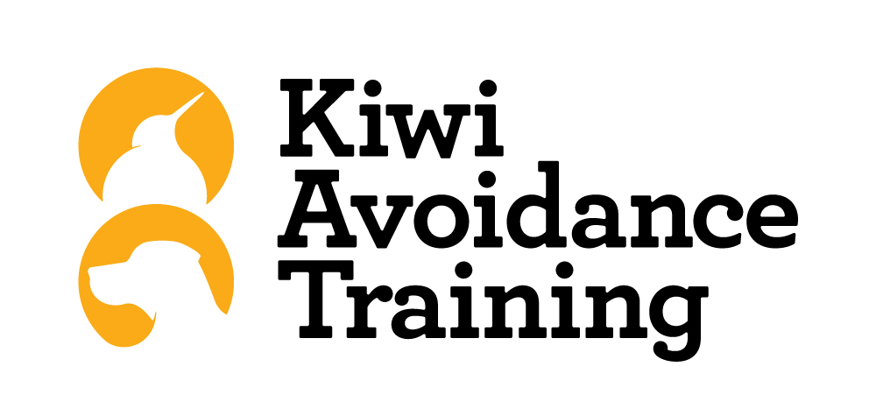

Kiwi Avoidance Training Events

Near Miss / Incident / Accident
Report & Investigation Form

This form must be completed with corrective actions and signed off within 48 hours of any near miss, accident or incident occurring

1. Person(s) Involved:

Name:

Contact No: ______________

Employee: Contractor: Other (Specify):

2. Details of near miss / incident / accident:

Location:

Date: Time: am / pm

3. Severity:

Fatal Serious Harm Minor Harm No Harm / Near Miss

4. Treatment:

Nil First Aid H&CC Doctor Hospital

What treatment was given ?

By Whom

5. Description of what happened:

6. Describe the cause of the near miss / incident / accident:

Contributory Factors (refer to these when identifying the cause of the near miss / incident / accident)

Immediate Causes Substandard Acts
- - Operating without authority
- Defective tools or equipment - Disabling safety devices
- Hazardous arrangements - Using unsafe equipment
- Unsafe conditions - Non use of Personal Protective Equipment
- Unsafe design - Incorrect use of PPE
- Housekeeping - Unsafe positioning
- Environmental conditions - Distraction / fooling about

7. Has a significant hazard been identified ? Y / N

If yes, please investigate this hazard and update the Hazard Register

8. Chance of the near miss, incident or accident recurring:

One off Daily Weekly Monthly 6 Monthly +

9. Corrective Action: (What will be done to minimise the risk of this happening again)

Action By Whom Completed

Person in control of the KAT site: Name:

Signed: Position:

10. Managing Director Comments:

Signed: Position:

Date:

11. Near Miss / Incident / Accident recorded on Accident Register and all corrective actions completed:

Signed: Date:

Retain a copy on file

